EXPERMENT -1.

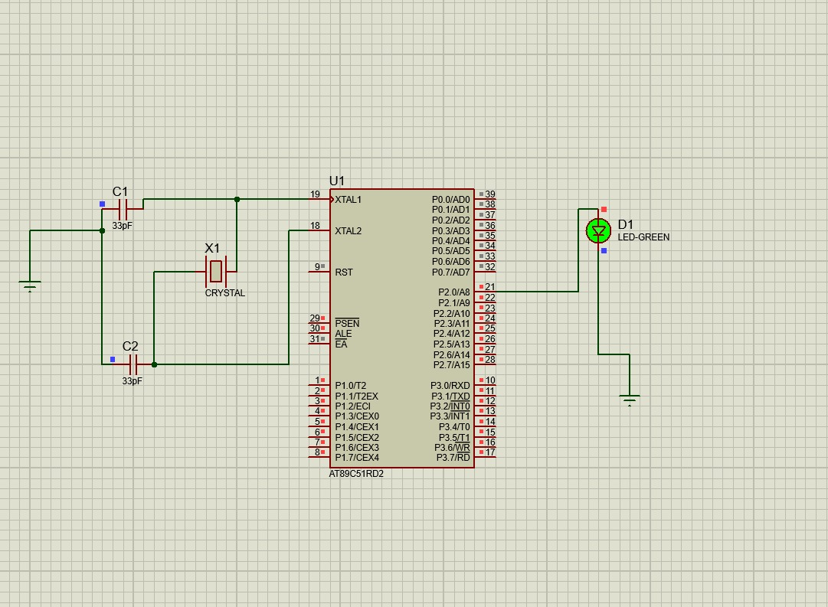

CODE :
ORG 0000H

UP:
SETB P2.0 ; Turn ON LED connected to Port 2.0
ACALL DELAY ; Call delay subroutine

CLR P2.0 ; Turn OFF LED
ACALL DELAY ; Call delay subroutine

SJMP UP ; Repeat forever

DELAY:
MOV R4,#35 ; Load outer loop counter
H1:
MOV R3,#255 ; Load inner loop counter
H2:
DJNZ R3,H2 ; Decrement R3 until 0
DJNZ R4,H1 ; Repeat outer loop
RET ; Return from delay

END
EXPERMENT-2 :
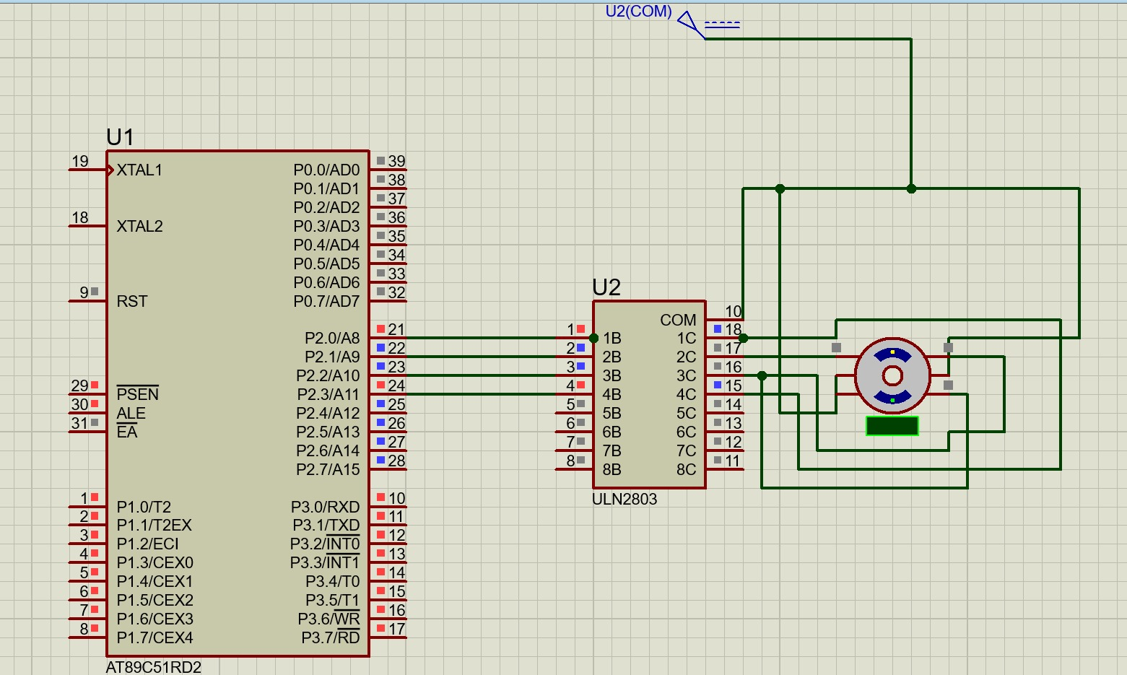

CODE :
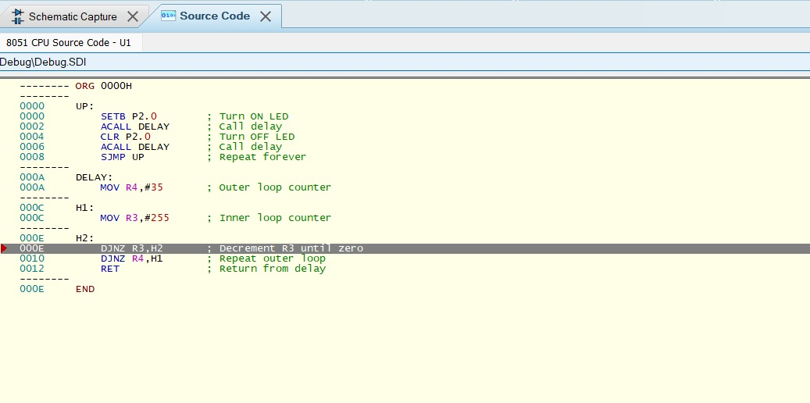

EXPERMENT -2


CODE :
